Task 7
Operating system (lab)
Name :Nabiha Sabir
Roll no: su92-bssem-s24-019
Section :4A
Subject :operating system (lab)

Question 1: Write a Python program to simulate a simple paging system where each process page is mapped to a random frame.
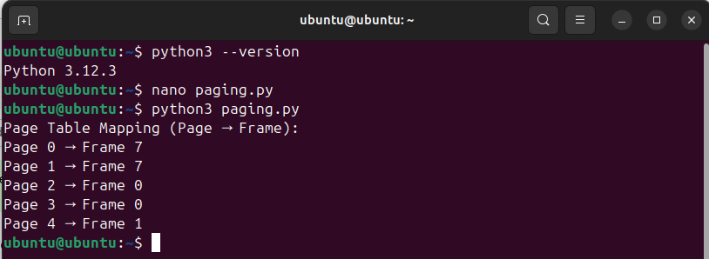
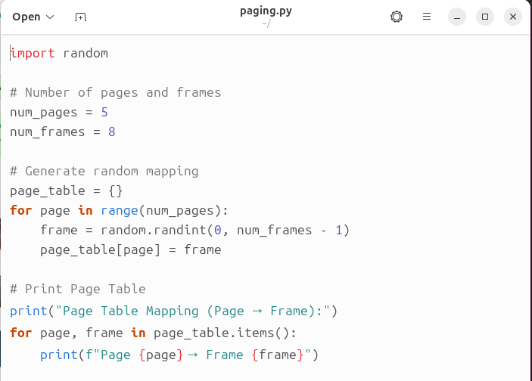
Question 2: Write a program to display the base and limit address for each segment (Code, Data, Stack).
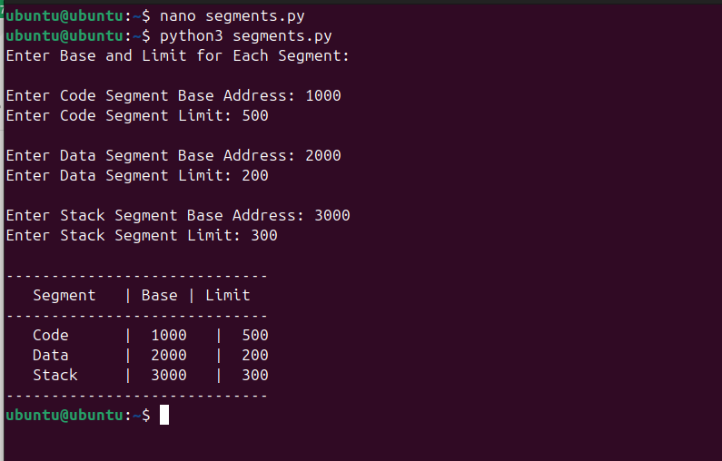

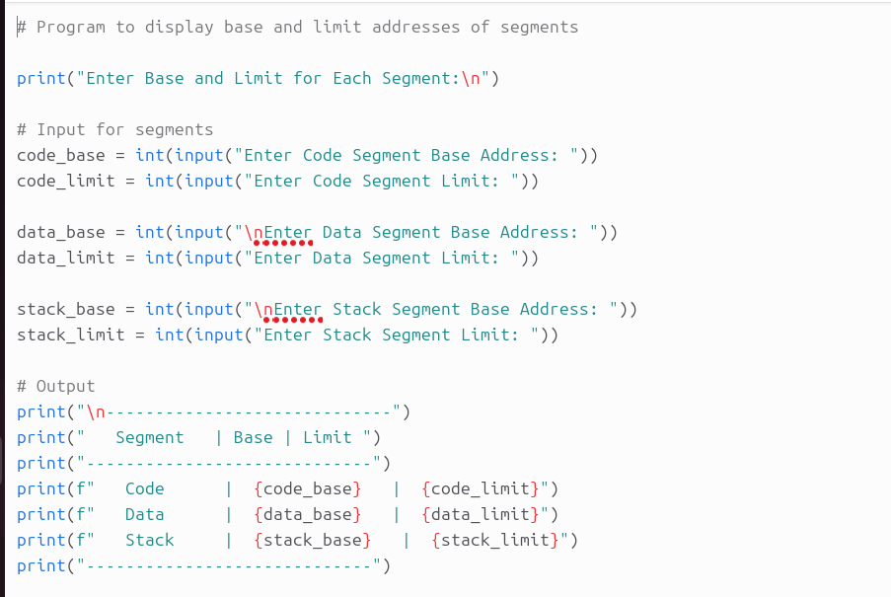
Question 3: Write a program that divides each segment into pages and maps those pages to frames. import random
import math

# Page size (fixed)
PAGE_SIZE = int(input("Enter Page Size: "))

# Input segment base and limit
segments = {}
for seg in ["Code", "Data", "Stack"]:
base = int(input(f"\nEnter {seg} Segment Base Address: "))
limit = int(input(f"Enter {seg} Segment Limit: "))
segments[seg] = {"base": base, "limit": limit}

# Total number of frames in memory
total_frames = int(input("\nEnter Total Number of Frames: "))

print("\n--- Paging Simulation ---")

# For each segment
for seg_name, seg_info in segments.items():
base = seg_info["base"]
limit = seg_info["limit"]

# Calculate number of pages for this segment
num_pages = math.ceil(limit / PAGE_SIZE)

print(f"\nSegment: {seg_name}")
print(f"Base Address: {base}, Limit: {limit}")
print(f"Number of Pages: {num_pages}")

# Map each page to a random frame
page_table = {}
for page in range(num_pages):
frame = random.randint(0, total_frames - 1)
page_table[page] = frame

# Display page → frame mapping
print("Page → Frame Mapping:")
for page, frame in page_table.items():
print(f"Page {page} → Frame {frame}")
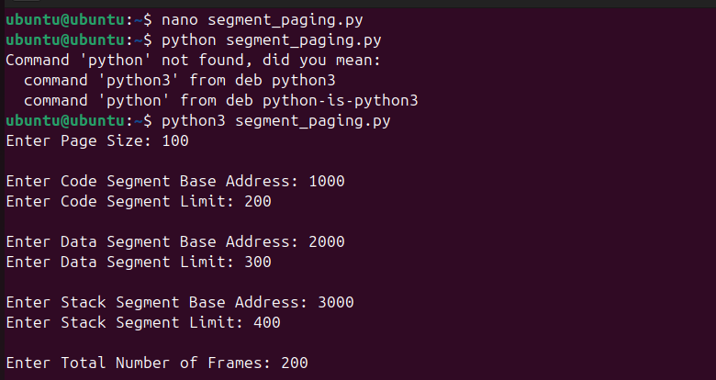
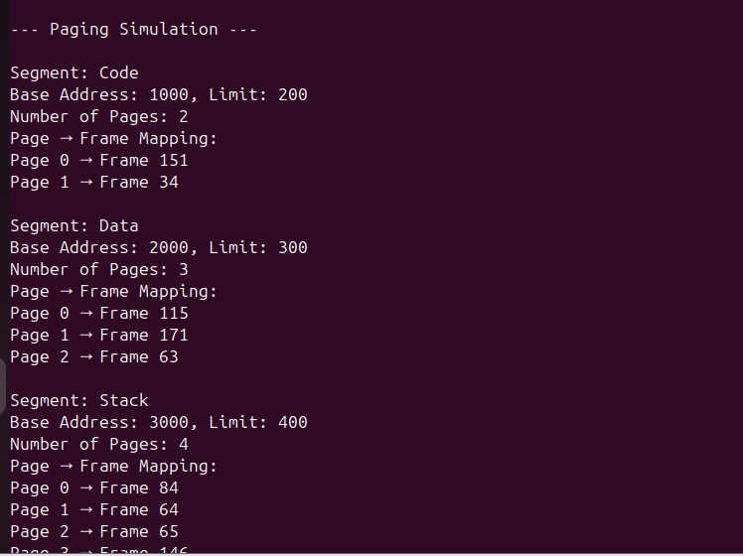

Question 4: Write a Python program that combines both paging and segmentation. Each segment should be divided into pages, and those pages should then be assigned to physical memory frames (simulate a modern OS memory management system).
import random
import math

print("=== Segmentation and Paging Simulation ===\n")

# Step 1: Input Page Size
PAGE_SIZE = int(input("Enter Page Size: "))

# Step 2: Input Segments Base and Limit
segments = {}
for seg in ["Code", "Data", "Stack"]:
print(f"\nEnter details for {seg} Segment:")
base = int(input("Base Address: "))
limit = int(input("Limit: "))
segments[seg] = {"base": base, "limit": limit}

# Step 3: Input total number of physical frames
total_frames = int(input("\nEnter Total Number of Frames in Physical Memory: "))

# Step 4: Process each segment
for seg_name, seg_info in segments.items():
base = seg_info["base"]
limit = seg_info["limit"]
num_pages = math.ceil(limit / PAGE_SIZE) # Number of pages

print(f"\n--- Segment: {seg_name} ---")
print(f"Base Address: {base}, Limit: {limit}, Number of Pages: {num_pages}")

# Step 5: Map pages to frames
page_table = {}
used_frames = set() # To avoid duplicate frames (optional)

for page in range(num_pages):
while True:
frame = random.randint(0, total_frames - 1)
if frame not in used_frames:
used_frames.add(frame)
break
page_table[page] = frame

# Step 6: Display page table for this segment
print("Page → Frame Mapping:")
for page, frame in page_table.items():
print(f"Page {page} → Frame {frame}")
